**NAME :** PRIYADHARSHINI P

**DEPARTMENT :** INDUSTRIAL BIOTECHNOLOGY

**COLLEGE :** GOVERNMENT COLLEGE OF TECHNOLOGY

**NAAN MUDHALVAN COURSE :** DIGITAL MARKETING

**NAAN MUDHALVAN ID :** DAD728D1F6D4AC8871040A6CD09E1710

**ASSIGNMENT ON DIGITAL MARKETING**

1.Create a blog or website using blogspot and wordpress.Customizethe theme design and post new article with 500 words.

Wordpress:

[https://mywindin.wordpress.com/2023/10/30/cosmetics-2/](%20%20https://mywindin.wordpress.com/2023/10/30/cosmetics-2/)

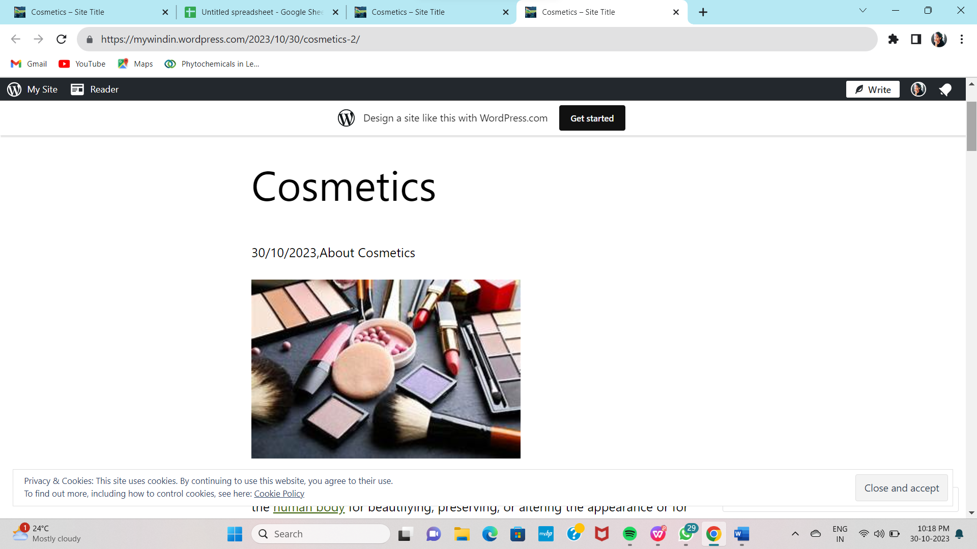

2.Create a new facebook business page and post one social media poster for your brand.

<https://m.facebook.com/story.php?story_fbid=122093486456104982&id=61553149460704&mibextid=Nif5oz>

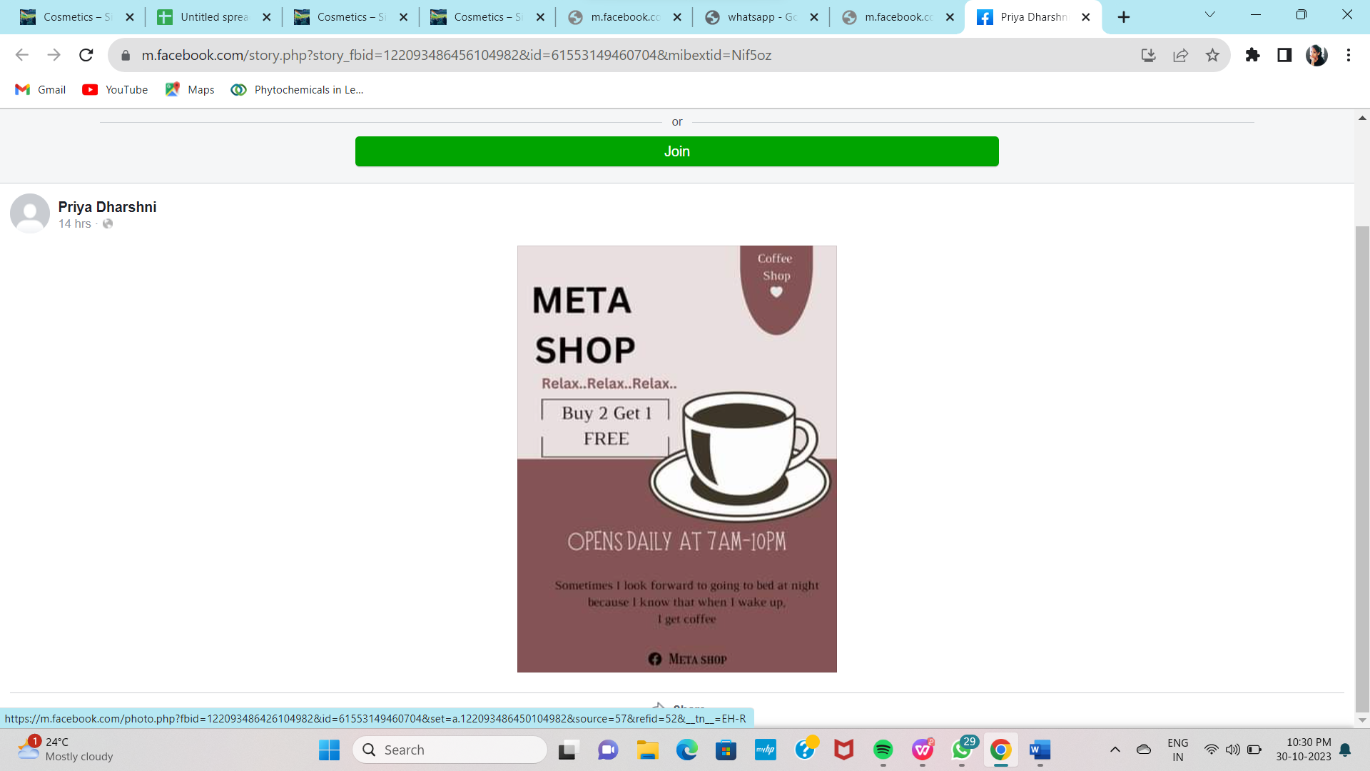

3.Create and design a social media advertisement poster using canva.



4. Create email newsletter design using Mailchimp or canva tool.

